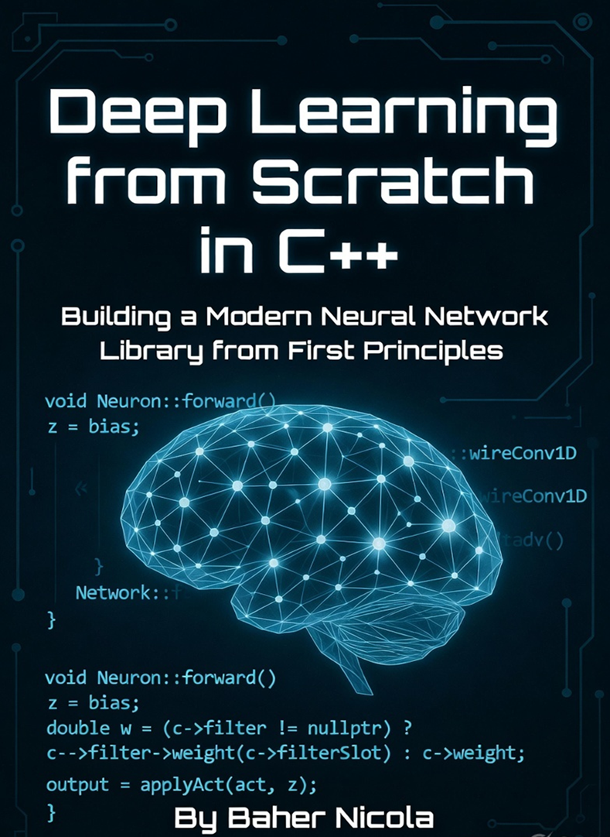

Deep Learning from Scratch in C++
Building a Modern Neural Network Library
from First Principles
Baher Nicola

[Publisher ]
2026

# Preface
The field of deep learning has transformed our world. From voice assistants to medical imaging and autonomous vehicles, neural networks are now everywhere. Yet most practitioners treat them as black boxes wrapped inside high-level frameworks like PyTorch or TensorFlow.
This book takes the opposite approach.
We will build a complete, modern neural network library **from scratch in C++** — using only the C++ Standard Library. No external deep learning frameworks. By the end of this book, you will have implemented dense layers, convolutional networks, residual connections, layer normalization, dropout, the Adam optimizer, and even a working natural language appliance controller.
Why C++?
**Performance**: You see exactly where the computational cycles are spent.
**Clarity**: No hidden autograd magic. Every gradient and weight update is explicit.
**Control**: You own the memory layout, the graph wiring, and the training loop.
**Deep Understanding**: Nothing teaches you neural networks better than building them yourself.
This book is for software engineers, students, researchers, and curious programmers who want to move beyond APIs and truly understand how deep learning works under the hood.
You should be comfortable with C++ (classes, pointers, and the STL). Prior deep learning experience is helpful but not required — I explain the necessary mathematics along the way.
The complete source code for the library developed in this book is provided and can be compiled and run immediately. Every chapter includes working examples you can experiment with.
This is a **builder’s guide** , the story of how we sit down and construct deep learning from first principles.
Welcome to the journey.
Baher Nicola

Table of Contents
Part I: Foundations
**Chapter 1: Why Build Neural Networks from Scratch? ** .......................................... 1
**Chapter 2: The Perceptron** ................................................................................. 15
**Chapter 3: Multi-Layer Networks and Backpropagation** ……………………….............. 35
**Chapter 4: Activation Functions and Loss** ........................................................... 65

Part II: Modern Deep Learning Components
**Chapter 5: Optimization with Adam** .................................................................... 85
**Chapter 6: Convolutional Neural Networks** ....................................................... 105
**Chapter 7: Regularization Techniques** ............................................................... 135
**Chapter 8: Residual Connections** ..................................................................... 155

Part III: Applications and Advanced Topics
**Chapter 9: Natural Language Appliance Controller** ............................................ 175
**Chapter 10: Image Classification with Conv2D + MaxPool** .................................. 205
**Chapter 11: Saving, Loading, and Production** .................................................... 225
**Chapter 12: Beyond This Book** .......................................................................... 245

Appendix A: Complete Library Reference
Appendix B: Mathematics Review
Bibliography
Index

